
TECHNICAL UNIVERSITY OF KENYA
FACULTY OF APPLIED SCIENCES AND TECHNOLOGY
SCHOOL OF COMPUTING & INFORMATION TECHNOLOGY
UNIVERSITY EXAMINATION EXAMINATION SERIES
THIRD YEAR EXAMINATIONS FOR THE DEGREE OF
BACHELOR OF TECHNOLOGY IN COMPUTER TECHNOLOGY
BACHELOR OF TECHNOLOGY COMMUNICATION AND COMPUTER NETWORKS
ECSI/ECCI3106 OBJECT ORIENTED ANALYSIS AND DESIGN
TIME: 2 Hours

Instructions to candidates:
This paper consists of FIVE Questions.
Answer Question ONE [30 Marks] and any other TWO Questions [20 Marks Each].
Write your college number on the answer sheet.
This paper consists of 3 printed pages
Candidates should check the question paper to ascertain that allthe pages are printed as indicated and that no questions are missing.

© The Technical University of Kenya Examinations

Page 1 of 3

QUESTION ONE [30 MARKS] COMPULSORY

- Explain the following terms as used in dynamic modeling
- State
- Transition
- Event
- Action [4 Marks]
- Outline any four benefits of the Object Model [4 Marks]
- With the help of diagram explain any four types of Inheritance [4 Marks]
- With the help of an example briefly describe the following concepts as used in object oriented
- Objects
- Class
- Operations [6 Marks]
- Discuss the input and output of object-oriented design. [6 Marks]
- Distinguish between the following
- Encapsulation and Polymorphism
- Generalization and Specialization
- Link and Association [6 Marks]

QUESTION TWO [20 MARKS]

- Discuss the building blocks of UML [6 Marks]
- With the help of a chart explain the classification of UML diagrams [7 Marks]
- Read the information below and answer the question that follow:
The shop sells in bulks and has a clientele comprising of merchants and retail shop owners. Each customer is asked to register with his/her particulars and is given a unique customer code, C_Code.
Once a sale is done, the shop registers its details and sends the goods for dispatch. Each year, the shop distributes Christmas gifts to its customers, which comprise of a silver coin or a gold coin depending upon the total sales and the decision of the proprietor.Develop a functional model of the Wholesale Software given above [7 Marks]

QUESTION THREE [20 MARKS]

- With the help of examples discuss the features of a DFD [12 Marks]
- Draw the Use Case Diagram of an ATM Machine system [8 Marks]
QUESTION FOUR [20 MARKS]

- Describe the Object-Oriented Software development life cycle [10 Marks]
- Read the information below and answer the question that follow
This is an Order Management System of an application. Here a Customer can have multiple Orders, but an Order is related to exactly one Customer. There are two types of Orders: SpecialOrder and NormalOrder. SpecialOrder and NormalOrder have all the properties as the Order. In addition they have additional functions like dispatch and receive
- Class Diagram
- Sequence Diagram [10 Marks]

Page 2 of 3

QUESTION FIVE [20 MARKS]

- Outline any Five advantages of Object Oriented Databases over RDBMS [5 Marks]
- Given the class diagram below write a code to implement using either C++ or Java [5 Marks]
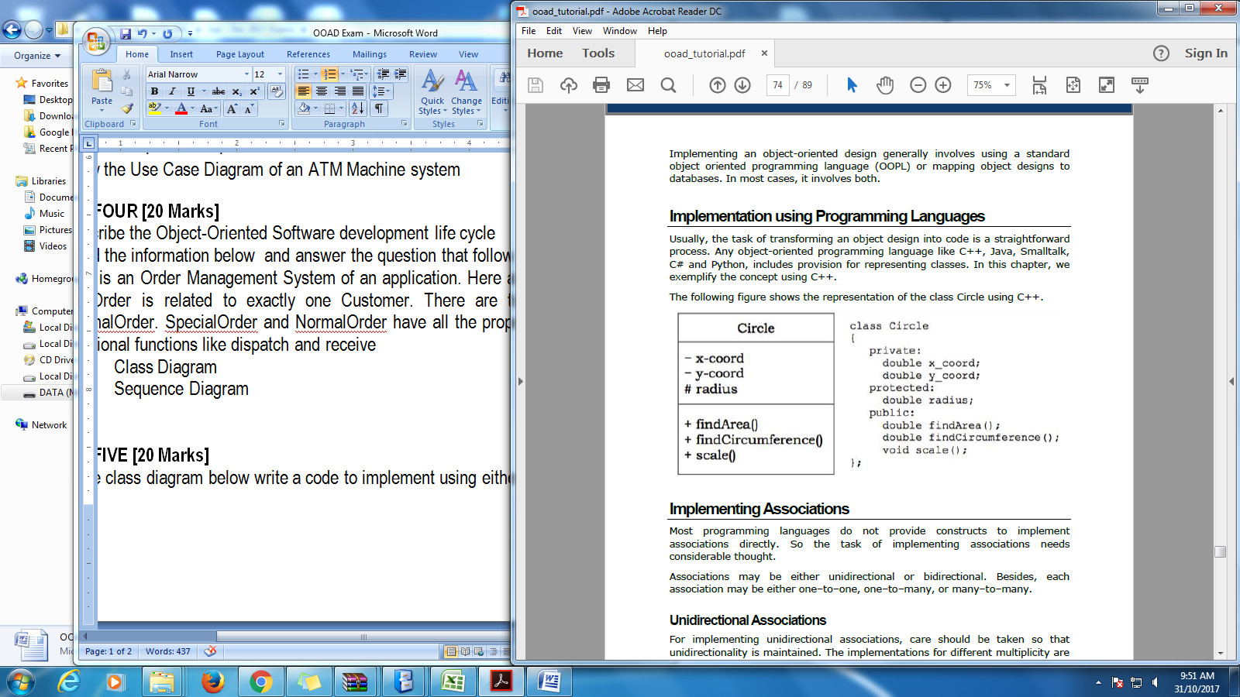
- Water can exist in several states - liquid, vapor, solid, and plasma. Several transitions are possible from one state to another. For example, freezing is phase change from liquid state to ice. Condensation is phase change from vapor state to liquid. Water vapor could turn directly into frost through deposition. Using the information above draw a well labeled state diagram [10 Marks]

Page 3 of 3

